Ministry One / ShelbyNext Membership

You can access our new church software thru the Ministry One App on your phone or mobile device or through your computer using the link below.

https://fbcwalnutcove.shelbynextchms.com

This will take you to the Login Screen and you will need to use the username and password that you were given when your account was set up.

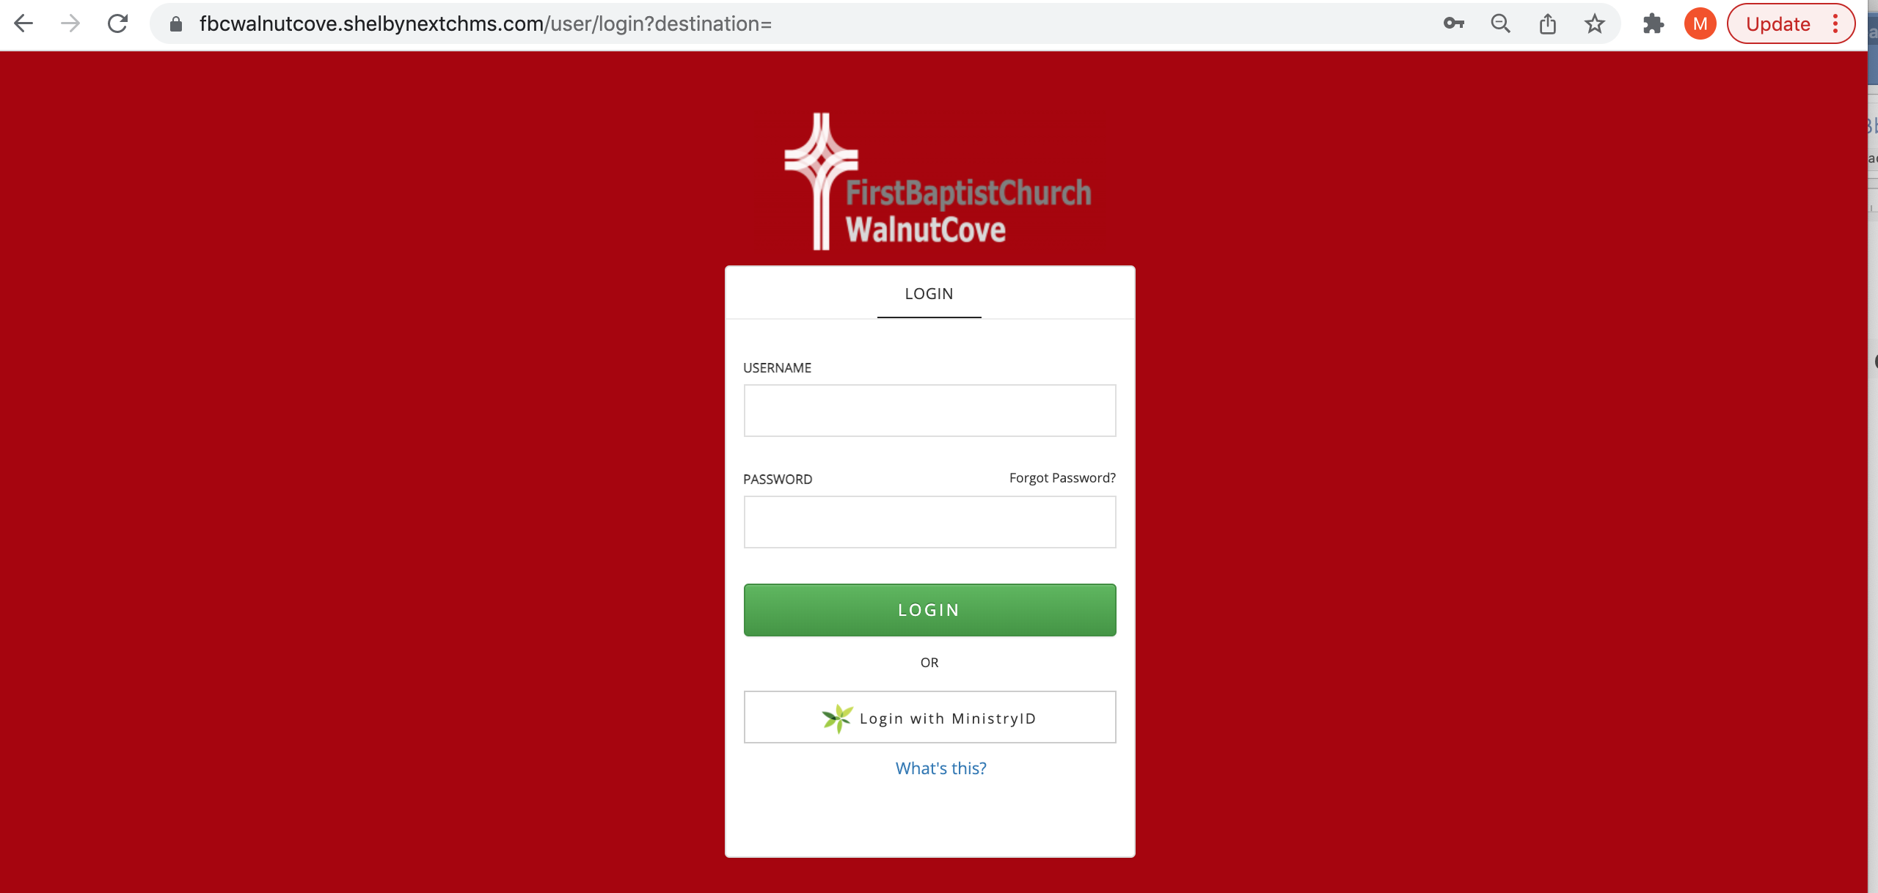

Once you Login you will see the following screen.
- You can click on the round circle with your initials in the top right corner to view and change your profile info
- You can click on the options on the left hand side to :
  - People – View and search the Online Directory
  - Groups – See the current list of groups that have been created for our Church
  - My Giving – See your personal giving History
  - Dashboard – Not currently in use yet

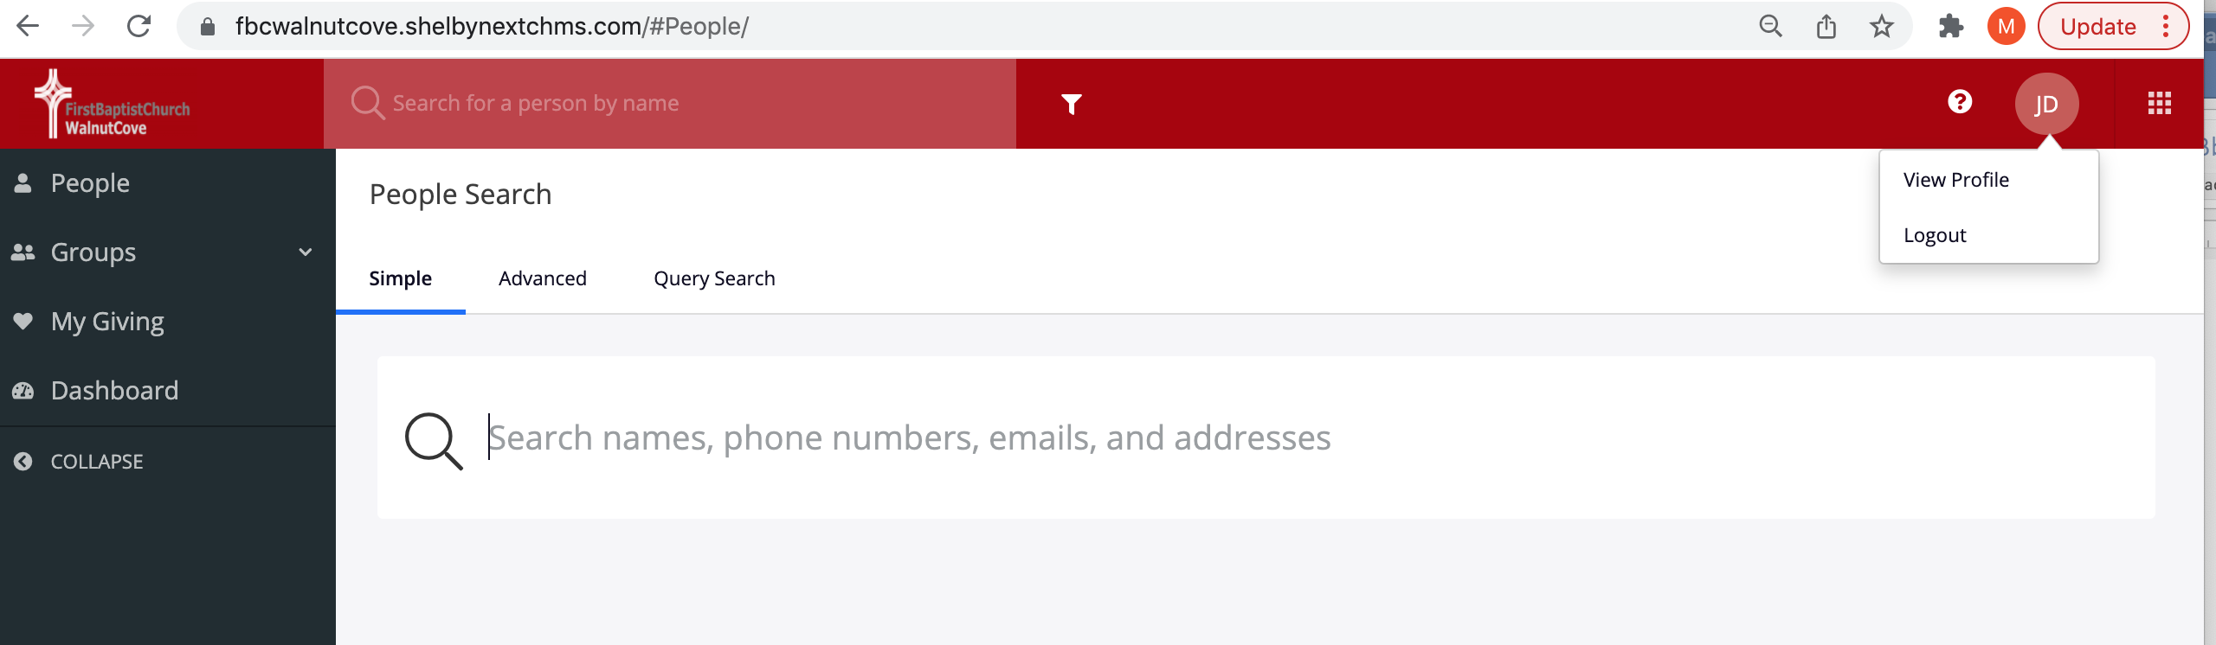

If you select View Profile you can manage your information. Things like address, phone numbers etc. You can also manage what information you share with others thru the Profile Visibility option.

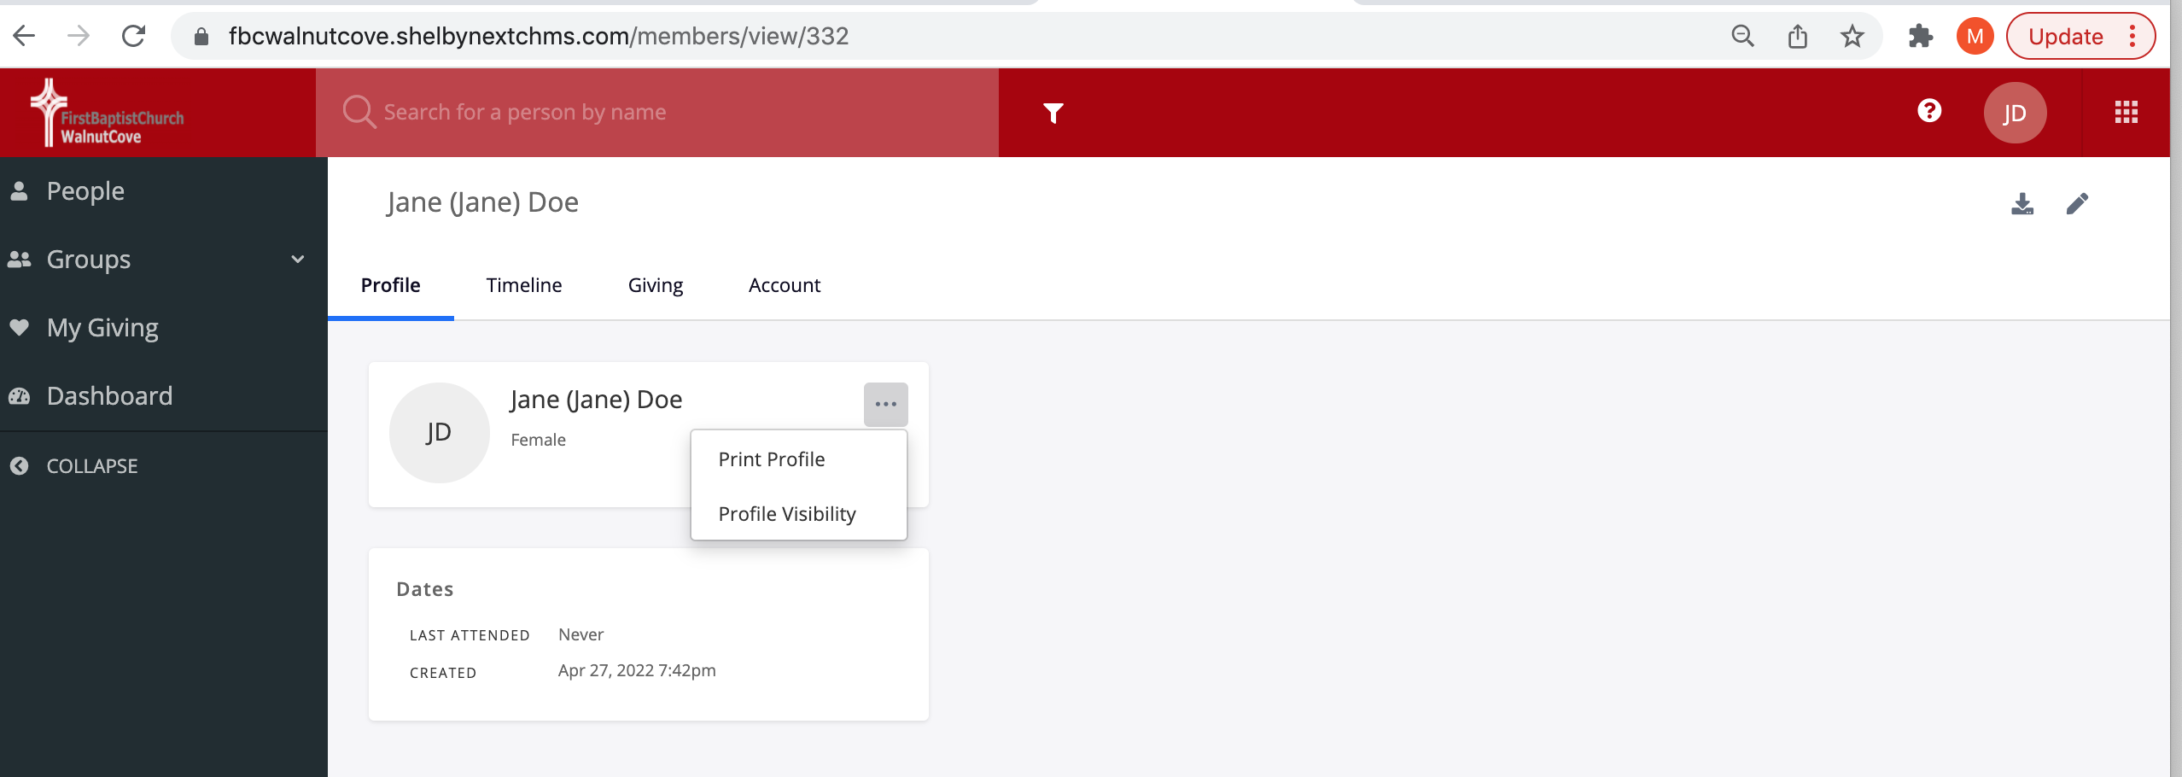

If you select Profile Visibility, you will see a pop up screen that will let you adjust the Circle slide bar to allow your information to be public in the directory or only to Group Leaders or not at all by leaving the circle on the far left as shown below.

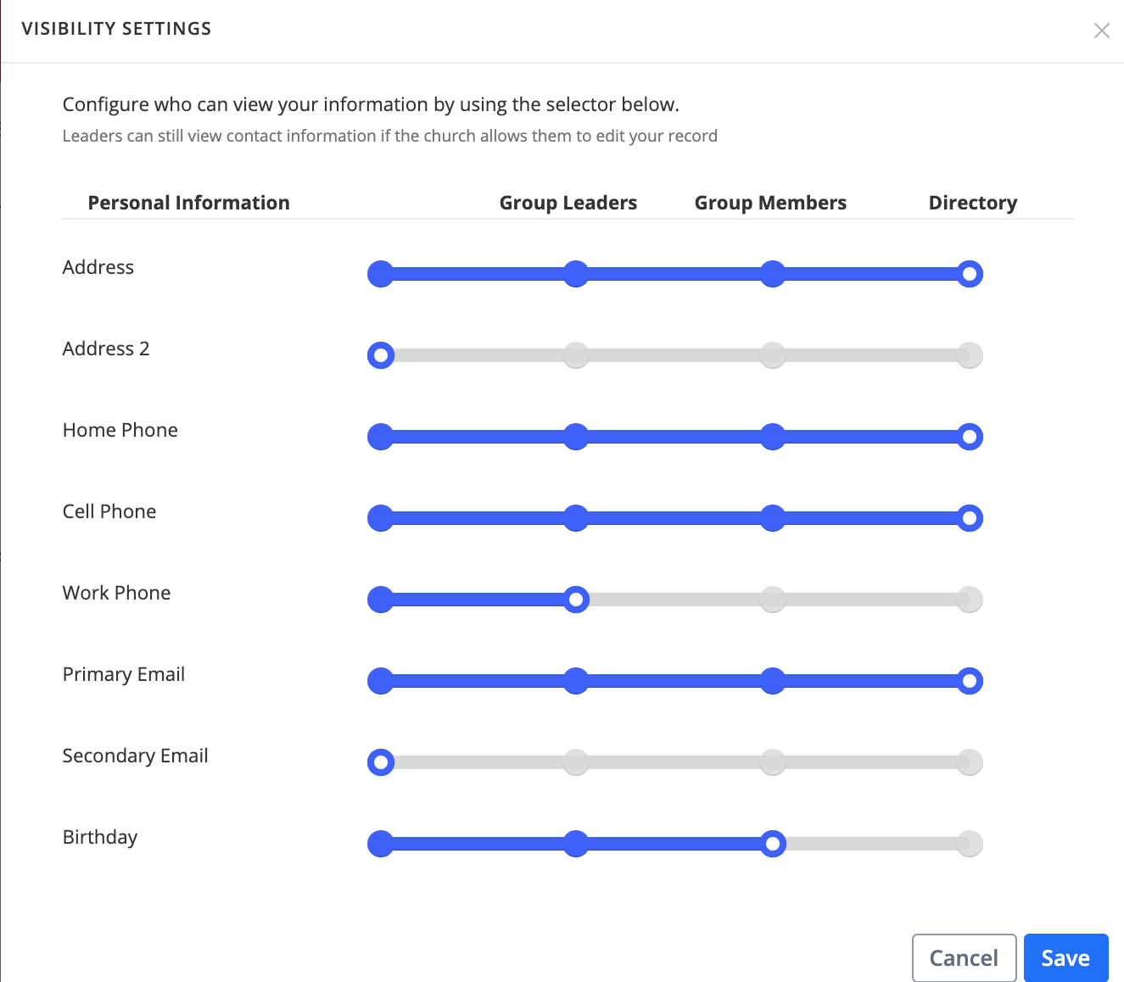

If you click on the Box of 9 dots in a square to the right of your Initials you can access the membership area, Church Calendar and Give Now options.

