Ministry One Installation Guide

We are excited about our new Ministry One Software. We believe it will be a great tool to improve communication and engagement for our church. This guide below walks you thru the install for an Iphone. Similar steps should also work for other types of phones.

Step 1: Install the Ministry One application.
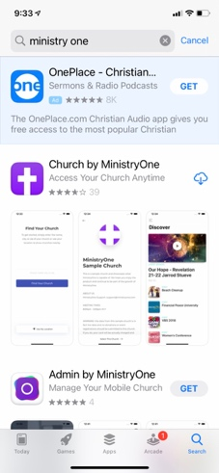
Search the app store by typing Ministry One in the search bar

Select the GET option for Church by Ministry One (Purple Cross) to install the application

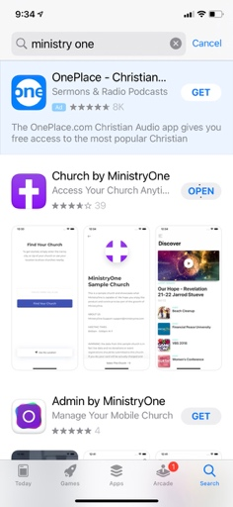
Click Open when the download completes

Step 2: Find and select the FBCWC Ministry One App

Enter Zip Code 27052 Click to Select FBCWC App
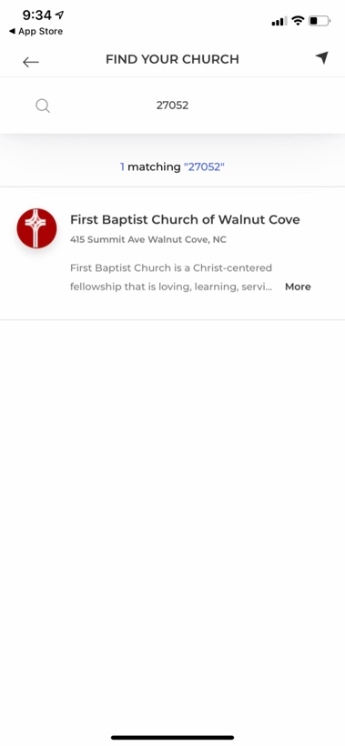
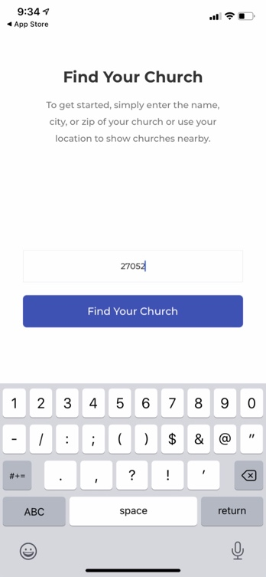

At the bottom Click Select This Church Next Allow “Church” to send notifications
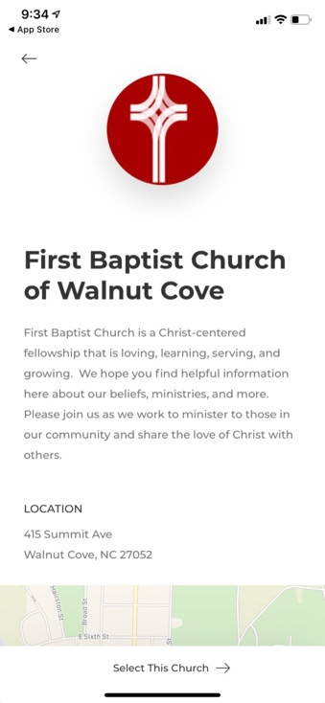
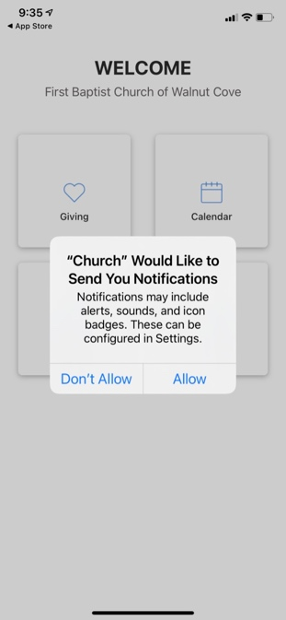

Step 3: Set up your Profile

Select the Profile tile Sign In using email & Mobile Phone number or
Username and Password from Email
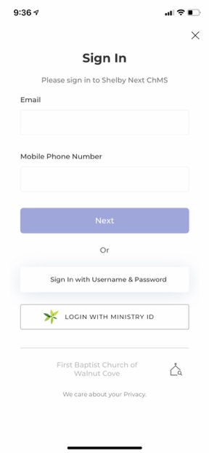
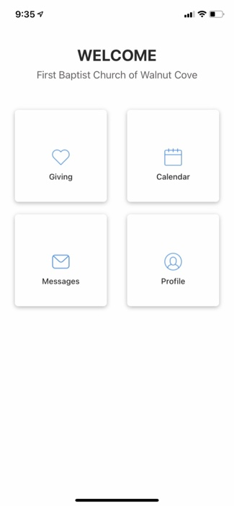

For added security If you used Email and Phone you will need to get a validation Code – Enter the validation Code
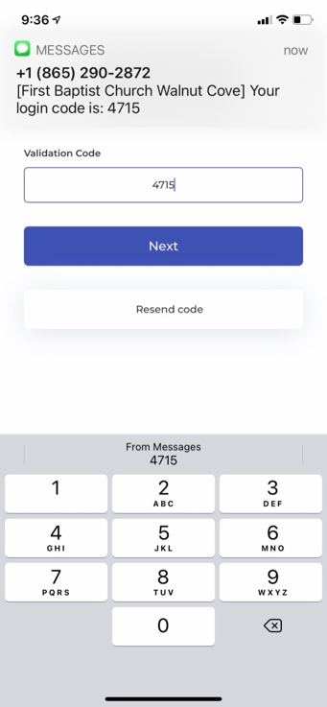
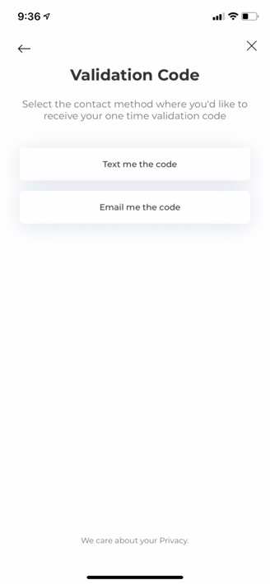

Step 4: Access your Profile by clicking on the Profile tile – You can then edit your Profile Picture, contact information and add Payment Info for Online Giving if desired. Once you’re ready to move on simply click the X in the top Right Corner
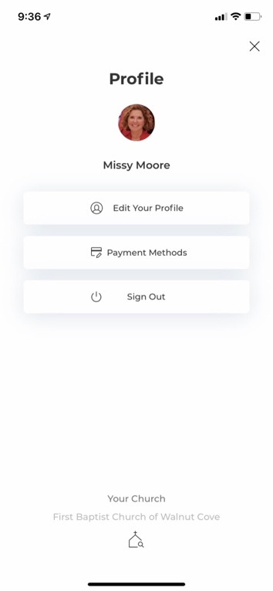
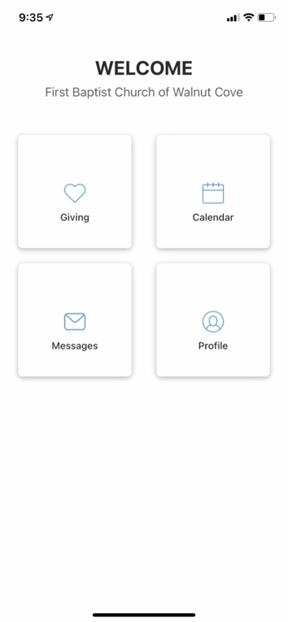

Your now ready to explore our Churches Ministry One application.

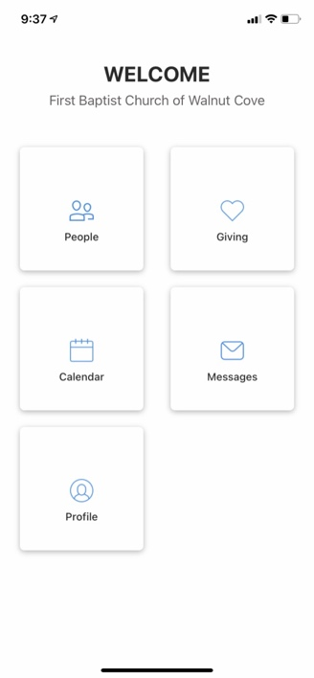
CALENDAR: You can see our Church Calendar, including events and Birthdays with this tile
GIVING : You can see Giving History with this tile – NOTE there may be some 2021 history but the plan is to have Giving History visible starting in 2022

PEOPLE :You can find People – In this tile you will see any Committees that you are a part of as well as online contact info for others.

At any time you can go back to the main Welcome area by clicking the Icon with the 4 squares in the top right corner

